Evaluation Criteria

Connor Cuffe

Beaumaris Secondary College

Table of Contents

Evaluation Criteria 3

Cost 3

Security 3

Reliability 3

Scalability 3

User experience 3

Functionality 3

# Evaluation Criteria

## Cost

* Zero cost for the life time of the product on both the user and developer ends.

## Security

* No evident major security flaws
  + A major security flaw is a flaw that would allow for the exposure of personal information or the impersonation of users.
* Less than five minor security flaws
  + A minor security flaw is a flaw that allows for the deletion of user data or the override of admin settings.

## Reliability

* Less than two software failures per 24 hours of use.
  + A software failure is defined as an unintended outcome that negatively affects the user experience.

## Scalability

* Can handle up to 100 users on one network with only minor performance losses.

## User experience

* Takes less than one hour to learn the user interface.

## Functionality

* Meets all of the functional requirements.
* Meets at least half of the non-functional requirements.

# User interface Mockup

## Mockup 1

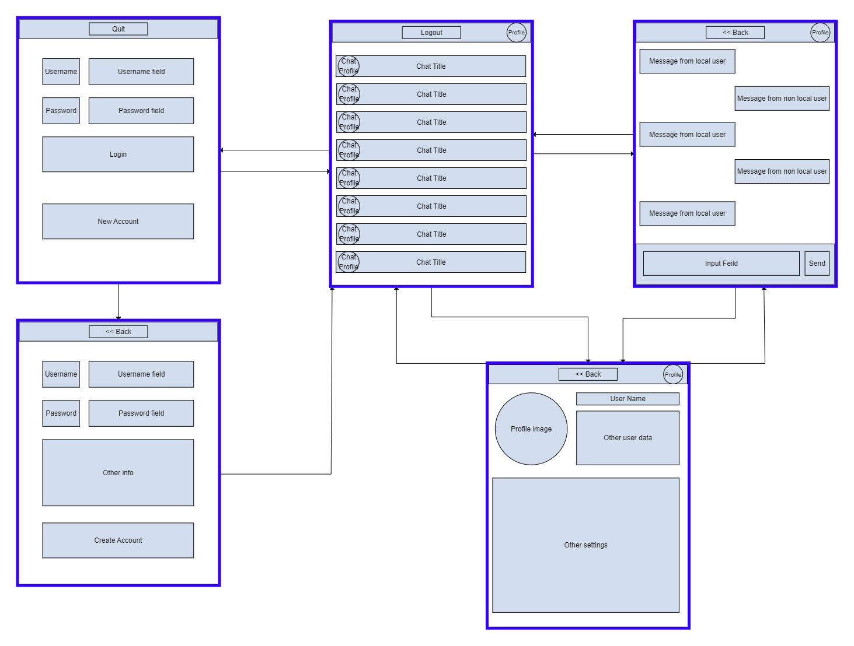

### Evaluation

#### Pros

* Similar to other messaging apps
  + Therefore, easy for users to migrate to.

#### Cons

## Mockup 2

### Evaluation

#### Pros

#### Cons

## Mockup 3

### Evaluation

#### Pros

#### Cons

## Final Decision